Requirement Collection and Analysis
Users of the system:
Listed below are the main users of the pharmacy management system. They are required to register into the system to access records and details stored in the database. Only the head admin has the privilege or access over all records and users. The system access to other users in restricted as per their functions in the medical store.
- Admin
- Manager
- Cashier
- Pharmacist
List of forms:
- Log in and Log out
- Registration
- Add, edit, update, and delete users
- Check
- Invoice
- Prescription: view and delete
- Stock: view and delete
- Stock pharmacist
Role of Admin
- Admin Can Manage All users
- Admin Can Manage Manager
- Admin Can Manage Cashier
- Admin Can Manage Pharmacist

Use case description for Login To System for Head admin
Use case name Login to System
Summary System validates the Head admin
Actor the Head admin
Precondition the login page must be displayed

Flow of Event:
This use case starts when a Head admin is not logged in to the system and goes to the login page.
1. The Head admin going to the login menu and click on it.
2. System prompts the Head admin for username and password
3. The Head admin inserts username and password to the fields.
4. System checks the username and password.
5. If the input were valid value then system will display general system of the pharmacy system.

Alternate Flows:
Step 5: if the username or password is not correct, the System displays an
Error message. And prompts for the correct username and password.
Step 5: if the Head admin tries to insert username and Password three times
Without restarting the System, it will close.
Step 1-4: if the user clicks on cancel, the system will go on the pharmacy Navigation page.
Post condition: username and password of the Head admin is Validated.
Use case description for Login To System for cashier admin
Use case name Login to System for Cashier admin
Summary System validates the Cashier admin
Actor the cashier admin
Precondition the login page must be displayed

Flow of Event:
This use case starts when the cashier admin is not logged in to the system and goes to the login page.
1. The pharmacy manager going to the login menu and click on it.
2. System prompts the Cashier admin for username and password
3. The pharmacy manager inserts username and password to the fields.
4. System checks the username and password.
5. If the input were valid value then system will display general system of the pharmacy system.

Alternate Flows:
Step 5: if the username or password is not correct, the System displays an
Error message. And prompts for the correct username and password.
Step 5: if the Cashier admin tries to insert username and Password three times
Without restarting the System, it will close.
Step 1-4: if the Cashier admin clicks on cancel, the system will go on the pharmacy Navigation page.
Post condition: username and password of the Cashier admin is Validated.
Use case description for Login To System for manager admin
Use case name Login to System for manager admin
Summary System validates the manager admin
Actor the manager admin
Precondition the login page must be displayed

Flow of Event:
This use case starts when the manager admin is not logged in to the system and goes to the login page.
1. The manager admin going to the login menu and click on it.
2. System prompts the user for username and password
3. The manager admin inserts username and password to the fields.
4. System checks the username and password.
5. If the input were valid value then system will display general system of the pharmacy system.

Alternate Flows:
Step 5: if the username or password is not correct, the System displays an
Error message. And prompts for the correct username and password.
Step 5: if the manager admin tries to insert username and Password three times
Without restarting the System, it will close.
Step 1-4: if the manager admin clicks on cancel, the system will go on the pharmacy Navigation page.
Post condition: username and password of the manager admin is Validated.

Use case name Register to System for Pharmacist admin
Summary System creates an account
Actor the Pharmacist admin
Precondition the login page must be displayed
Flow of Event:
This use case starts when a system user is not logged in to the system and goes to the login page.
- The System prompts the user for a username and password or register new account.
- The user selects registration option.
- The System prompts user for registration information, Username, password, etc
- The user enters in their information.
- System verifies information and creates account.
- The use case ends.
Alternate Flows:
- User clicks submit after entering information system asked for.
- System displays information with appropriate message to correct invalid information.
- User re-enters information.
Use case description for Login To System for Pharmacist admin
Use case name Login to System
Summary System validates the Pharmacist admin
Actor the Pharmacist admin
Precondition the login page must be displayed

Flow of Event:
This use case starts when the pharmacist admin is not logged in to the system and goes to the login page.
1. The Pharmacist admin going to the login menu and click on it.
2. System prompts the Pharmacist admin username and password
3. The Pharmacist admin inserts username and password to the fields.
4. System checks the username and password.
5. If the input were valid value then system will display general system of the pharmacy system.

Alternate Flows:
Step 5: if the username or password is not correct, the System displays an
Error message. And prompts for the correct username and password.
Step 5: if the Pharmacist admin tries to insert username and Password three times
Without restarting the System, it will close.
Step 1-4: if the Pharmacist admin clicks on cancel, the system will go on the pharmacy Navigation page.
Post condition: username and password of the Pharmacist admin is Validated.

Use case description the Head admin of the System modifies the system
Use case name modifies the system
Summary the Head admin of the System modifies the system in the database
Actor the Head admin

Flow of Event:
This use case starts when the Head admin accesses the system.
- The System displays the current list of record.
- The head admin selects the record he/she wants to modify.
- The system displays the corresponding information.
- The head admin edits the information accordingly and submits.
- The system updates the information.
Use Case ends.
Alternate Flows:
- The system displays an “Invalid Information” error after the Head admin submits the information and asks the head admin to re-enter the information.
- The Head admin re-enters information and clicks submit.

DATA FLOW DIAGRAM (DFD)
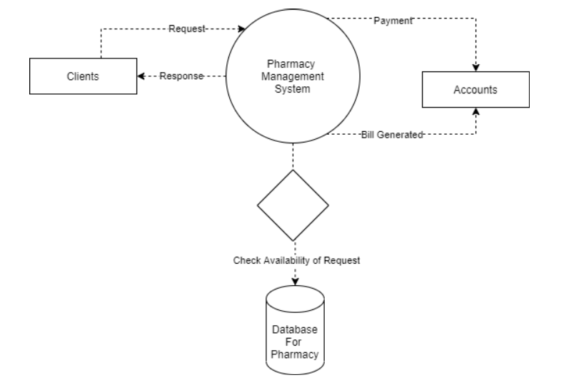 Data Flow Diagram of a Typical Pharmacy Management System
